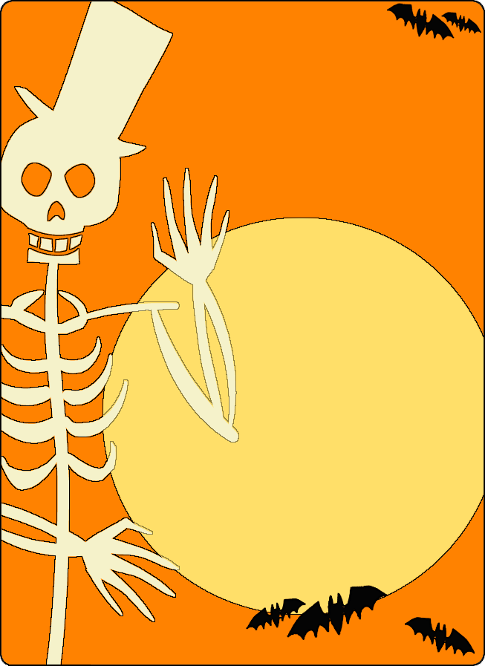
Halloween Party

October 27 at 9pm

The Quarry

Brittany Reilly Band 9pm
Best Costume $100
2nd Place $75
3rd Place $50
Complimentary appetizer buffet
Drink Specials

